The following health and safety guidelines relate to providing clean and sanitized facilities to allow a safe Return to Play. This has been developed using recommendations from the Provincial Government provincial health authorities.
Additional public resource documents can be found at: https://www.publichealthontario.ca/en/diseases-and-conditions/infectious- diseases/respiratory-diseases/novel-coronavirus/public-resources
Or
https://covid-19.ontario.ca/

Reduce Transmission

Office spaces, clubhouses, rental facilities, and training and competition areas should adhere to the following guidelines to minimize the risk of transmission of COVID-19:
- Any employee/player/parent/coach who is exhibiting symptoms of illness should stay home.
- Recognize and Assess – this virus is transmitted via droplets during close, unprotected contact with an infected person, or by touching an infected surface and then the eyes, nose, or moth. It can also cause a range of symptoms including, sore throat, cough, fever and shortness of breath.

If you, or someone you have been in contact with either at work, home, or at soccer related activities and begins to exhibit any of these symptoms, it is imperative to inform your Coach, Club/Academy representative immediately. In addition, you should:
  - Self isolate
  - Complete the online self-assessment available here; Ontario COVID-19 Self Assessment App
  - Contact Telehealth Ontario 1-866-797-0000
  - Contact your primary health care provider

Screening of all individuals should also take place at a minimum weekly, or as directed by local authorities.

Establish Controls

It is recommended that in order to reduce the possibility of transmission, it is important to establish controls, which need to be followed by all parties responsible for a safe Return to Play.

Offices
  - When feasible and with the coordination of your Supervisor, work from home as often as possible until government restrictions are relaxed.
  - When Return to Office is in affect, work surfaces, devices, laptops, screens, and equipment should be cleaned daily in accordance with established facility cleaning protocols.
  - Employees wash hands thoroughly with soap and water, or an alcohol-based hand sanitizer before entering the workplace, after contact with others, or when surfaces in contact with others have been touched.
  - Visitors sanitize hands prior to entering the offices and will be required to wear a mask.
  - Numbers of staff allowed into the office should be limited in accordance with provincial guidelines. Current regulations state two (2) metres (6 foot) distance required.
    - Practice physical distancing at all times while in the office.
    - Team/group meetings to take place outdoors, or in meeting rooms large enough to accommodate physical distancing rules.
    - Lunchroom should be off limits for eating. Food can be heated but lunch can take place outside or designated area observing social distancing.
    - Do not enter rooms/spaces where 2 meter distance cannot be maintained, including washrooms.
    - Facemasks should be worn when physical distancing cannot be maintained or guaranteed, i.e., meetings, walking to washroom, etc.
    - As staffing levels increase it may be necessary to implement rotating shifts or install protective barriers to ensure that physical distancing is maintained.
  - Workplace, common spaces and readily accessible areas to be cleaned and sanitized thoroughly and often, and in accordance with established facility cleaning protocols.
  - All staff and visitors should be required to sign in and out to ensure that contact tracing will be possible.
  - Any in-person deliveries, visits or meetings that are not deemed priority should be rescheduled to another date or be conducted online.
The use of central ventilation for heating and cooling to be minimized when possible.
  - Open windows and doors where feasible, and use fans to force in fresh outdoor air to minimize the amount of recycled indoor air.
  - Employees that do not feel well should not come to the office.
  - Use of facemasks and gloves are recommended and should adhere to government directives for work pace health and safety.

Field/Clubhouse

  - Ensure alcohol- based hand sanitizer, cleaning solution and disposable towels are present and readily accessible for each session.
  - Prior to entry and at the end of each session, all individuals to properly sanitize hands.
  - Establish and clearly define separate entrance and exit locations to field/clubhouse.

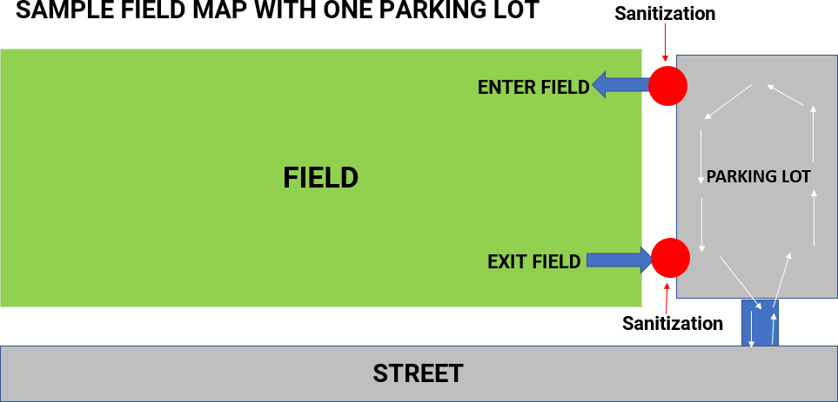

  - Control entry and exit to ensure physical distancing is observed. Parents should not be allowed onto field of play and should be directed to an approved viewing location. It is important to ensure NO gatherings of large groups while activity is taking place. Please respect social/physical distancing measures as set in place by governmental public health authorities.
  - Ensure method of accurately tracking players/parents/coaches in attendance at each session to assist in contact tracing, if required.
  - Screening for symptoms of players/parents/coaches to take place before each session. If symptoms present ensure the following steps are followed:
    - Individual moved to isolated area (with parent/guardian as necessary).
    - Field/facility vacated and sanitized.
    - Contact Telehealth Ontario 1-866-797-0000 and advise of situation.
  - Define areas on field, where space is possible, for individual storage of personal items:
    - Ensure spacing of two (2) metres (6 feet) is observed.
    - Players bring and use personally marked water bottles. No sharing of water bottles permitted.
Place personal items on a hard surface location, which can be easily cleaned and sanitized frequently, away from spectators. i.e., sidewalk, individual plastic bins, plastic covered tabletop
    - All items brought to the field in easily distinguishable individual player bags, and all items removed at the end of session. Anything left on field to be disposed of promptly and safely.
  - Clean and disinfect team benches, score clocks, water fountains or other commonly touched surfaces.
  - Facility change rooms are closed until government orders are lifted, except in cases where washroom facilities do not exist elsewhere and need to be accessed.
  - Communicate with field provider (private or municipal) to ensure cleaning and acceptable use guidelines have been developed, and that all protocols established are being adhered to. Copies of protocols should be requested and/or publically posted.
  - Commonly touched surfaces should be cleaned using appropriate sanitizing solution at the beginning and end of each session. Those surfaces should include but not limited to:
    - Door handles,
    - Tables,
    - Gate entrances,
    - Equipment (balls, training supplies, etc.),
    - Player equipment storage locations, and
    - Bleachers or seating used by spectators.
  - No sharing of personal items such as water bottles, goalie gloves, shin guards, pinnies, towels, etc.
  - Do not allow food of any type to be consumed at the field/facility.

Cleaning Recommendations:

Washroom and Change Rooms

  - Wet mopping of floors and shower floors/walls with 30:1 bleach solution.
  - Thorough cleaning of all fixtures, toilets, countertops, dispensers, doors, handles with approved sanitizing solution minimum two times per day or when visibly soiled.
  - Fogging of entire space using approved sanitizing solution is optional.

Office Space

- Wiping down of desktops, door handles, dispensers, countertops, storage, phones/handsets, photocopiers with approved sanitizing solution minimum two times per day or when visibly soiled.
- Wet mop hard floor with 30:1 bleach solution.
- Fogging of office space minimum of two occasions, six hours apart prior to staff return is optional.

Field/Clubhouse

- Wet mopping of hard floors with 30:1 bleach solution.
- Thorough cleaning of all fixtures, dispensers, water fountains, door handles, fire extinguishers, vending machines, emergency devices, benches, time clocks minimum two times per day, when visibly soiled, and in between each rental group.
- Fogging of all open spaces minimum of two occasions, six hours apart prior to re- opening of facility is optional.

