Covid-19 Emergency Response Plan

Plan Overview
This plan is organized into three sections, which outline the key roles and responsibilities of the Club in each of three pandemic phases: Pre-pandemic phase, Positive test phase, Post-pandemic phase.

Pre-Pandemic Phase
This is the critical phase for Covid-19 pandemic preparedness. Planning efforts focus on education of the volunteers, staff, coaches, parents, players, and match officials about Ontario Soccer and Canada Soccer’s Return to Play plans and protocols. Please note that the Return to Play Protocols comply with the Province of Ontario emergency orders and health authority directives. In addition, coordination with facilities are included here.
Pre-Pandemic Activity | Responsibility | Completed
Determine emergency response plan (ERP) lead person for the Club
Create Covid ERP or add to existing ERP and include a section on pandemic influenza
Complete Canada Soccer/Ontario Soccer's risk assessment online
Incorporate Canada Soccer/Ontario Soccer's Return to Play protocols into current operational plans
Educate all Club leaders of ERP
Create communication plan flow-chart if a positive test for Covid-19 in the Club
Verify Ontario Soccer, Province of Ontario, and local municipal government permissions for return to play implementation following Ontario Soccer return to play protocols of implementation

Positive Test Phase
Confirmation of a positive test within the Club will declare when it’s time to activate this phase of the Emergency Response Plan. During this phase, the key goals will be to prevent further infections within the Club. This phase remains active until the infected party is isolated and under the control of professional health authorities and there is no further threat to the health and safety of the Club’s participants.
Positive Test Phase Activity | Responsibility | Completed
Communication System: Consistent with Federal and Provincial/Territory privacy regulations, acts, laws, etc. coaches, staff, officials, and families of players should self-report to the ERP Lead (noted in phase 1) if they have symptoms of Covid-19 OR a positive test for Covid-19 is recorded, OR were exposed to someone with Covid-19 within the last 14 days. Note: See ERP Communications Flow Chart at end of this section
Advise Sick Individuals to stay home: Sick coaches, staff members, officials or players should not return until they are well enough based on Public Health Agency of Canada and Provincial Health Authority guidelines
Isolate and/or Transport those who are sick at Club Activities: Make sure that coaches, staff, officials, players, and families know that sick individuals should not attend a Club or Academy activity, and that they should notify officials if they (staff) or their child (families) become sick with COVID-19 symptoms, test positive for COVID-19,or have been exposed to someone with COVID-19 symptoms or a confirmed or suspected case.
Coaches, staff, officials, and players with COVID-19 symptoms (i.e., fever, cough, shortness of breath) at any club activity must be immediately separated and isolated. Individuals who are sick should go home or to a healthcare facility, depending on how severe their symptoms are, contact their Family Physician, and follow Health Agency guidance for caring for oneself and others who are sick. Individuals who have had close contact with a person who has symptoms should be separated and sent home as well. If symptoms develop, individuals and families should follow Health Agency guidelines for caring for oneself and others who are sick.
Establish procedures for safely transporting anyone who is sick to their home or to a healthcare facility. That means having parent contact information readily available; parents within a safe, socially distanced but easily accessible waiting area; or if you are calling an ambulance or bringing someone to the hospital. If calling an ambulance, please alert them that the person may have COVID- 19.
Clean and Disinfect Areas: Close off areas used by a sick person and do not use these areas until after cleaning and disinfecting them (for outdoor areas, this includes surfaces or shared objects in the area).
Ensure safe and correct use and storage of cleaning and disinfection products, including storing them securely away from children.
Notify Local Health Officials and Close Contacts: In accordance with Federal, Provincial and Territorial privacy and confidentiality laws and regulations, the SPOC should notify local health officials, Provincial or Territorial Associations, club staff, officials, and families immediately of any case of COVID-19 while maintaining confidentiality in accordance with applicable laws and regulations.
SPOC should work with local health officials to develop a reporting system (e.g., letter) to notify health officials and close contacts (logs and/or contract tracing information) of cases of COVID- 19.
The Provincial and Territorial Health agencies and their Contact Tracing procedures will be responsible for advising those who have had close contact with a person diagnosed with COVID-19 and determine whether someone should stay home and self monitor for symptoms. Members of the Club/Academy should continue to self-monitor for symptoms.
The SPOC must notify the Provincial or Territorial Association of any cases of COVID-19. A weekly reporting system should be instituted for SPOC to advise the Provincial or Territorial Association of any cases of COVID 19, suspected cases, and where athletes or staff have been refused admittance to any training session. Even if there are no suspected cases, a ‘nil’ report should be required.

Post-Pandemic Phase
This phase begins when the Provincial Health Officer declares that the Covid-19 pandemic is over. The primary focus of work at this time is to restore normal services, deactivate pandemic response activities, review the impact, and use the lessons learned to guide future emergency response planning.
Post-Pandemic Phase Actions and Communications | Responsibility | Completed
Confirm Provincial Health Officer has declared that the Covid-19 pandemic is over
Send official written notice to membership and stakeholders that the pandemic is officially over, the province's state of emergency order has been lifted and the Club can resume its full operations. Note: During this phase there may be specific sport protocols to follow from Canada Soccer/Ontario Soccer and/or the provincial health authorities (ie implementation of infection control policies and procedures
Conduct a full review of Club Covid-19 Return to Play Implementation Plan as well as Covid-19 Emergency Response Plan. Include a list of recommendations for improvements.
Update Club Emergency Response Plan for future use and have approved

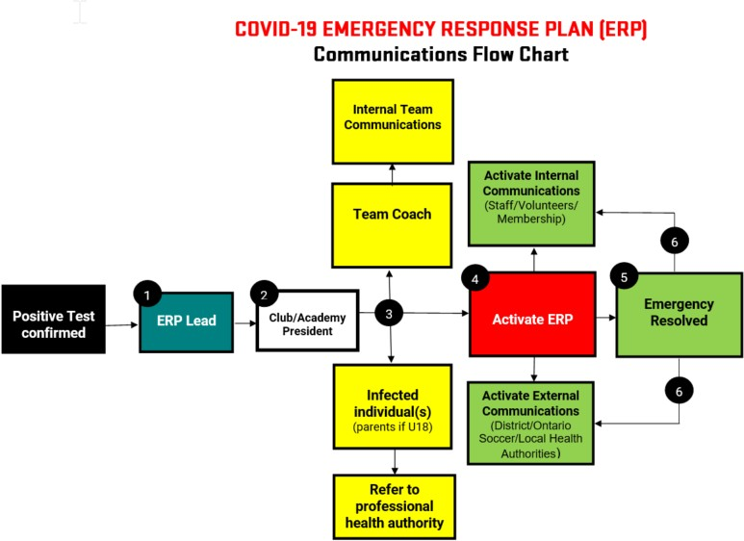
Communications Flow Chart Example:

This document is a template only, prepared to make the process of preparing for return to play easier for Clubs. Clubs must read the entire Ontario Soccer Return to Play Guide in its entirety and take full responsibility for their Emergency Response Plan.
“Please note that content used cannot be used in a manner that does not align with Ontario Soccer and the Government of Ontario’s COVID-19 directives, protocols and guidelines that are in place now and in the future.”

